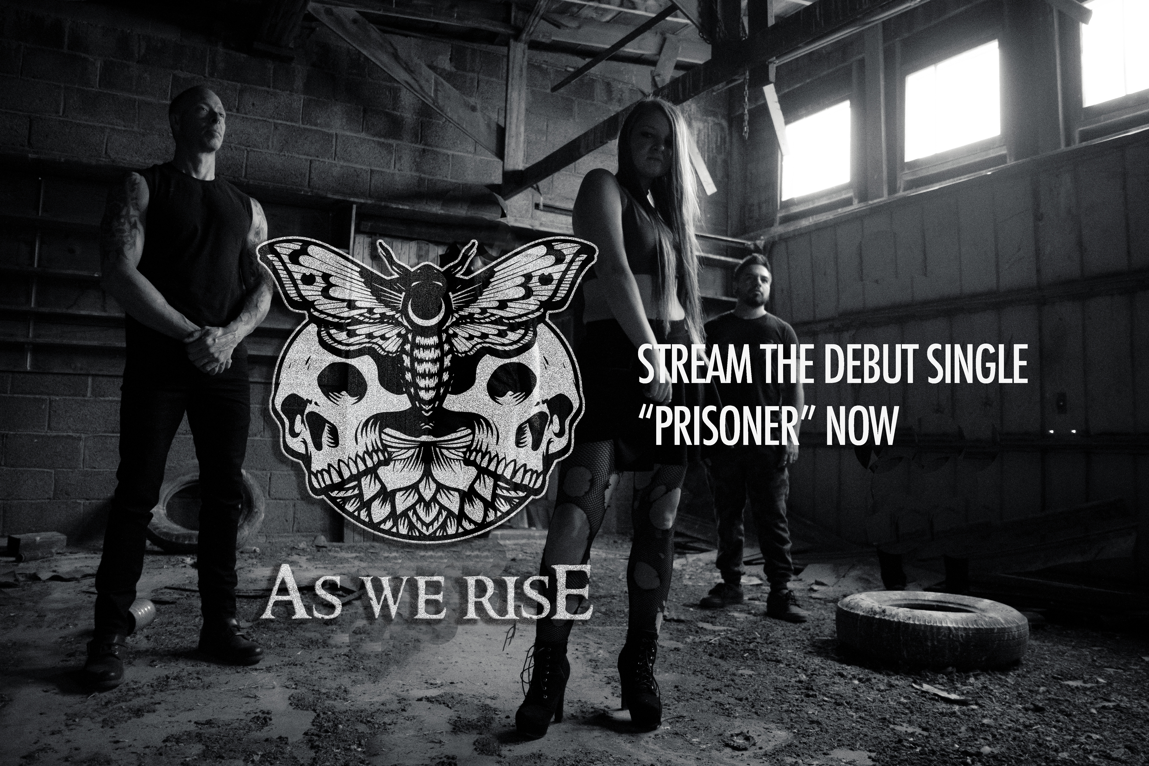

More at: www.asweriseofficial.com

AS WE RISE

Human Positive Aggression
AS WE RISE is ready to create that connection. You know, THAT connection. The one you had once when you left the venue feeling completely alive. Lives changed that night and it will never be forgotten. Everyone has a show like that, no matter which side of the lights you're on.

This is the beauty of the live experience. We view this interaction as an experiment yielding unique results each time. Its unpredictability is both magical and terrifying in the same breath. Music moves people. And it's that connection that moves the music creators. No BS, just raw emotion. This type of snapshot firing like a synapse sparking someone else’s life is one of the most monumental things one can gift to another.

We look forward to sharing that symbiotic moment with you and hopefully we give back the energy we feel in each of those special moments.

New EP, 2023. Coming to a venue near you.

For more on AWR’s origins:
http://voyagedenver.com/interview/check-out-the-as-we-rise-story/

